[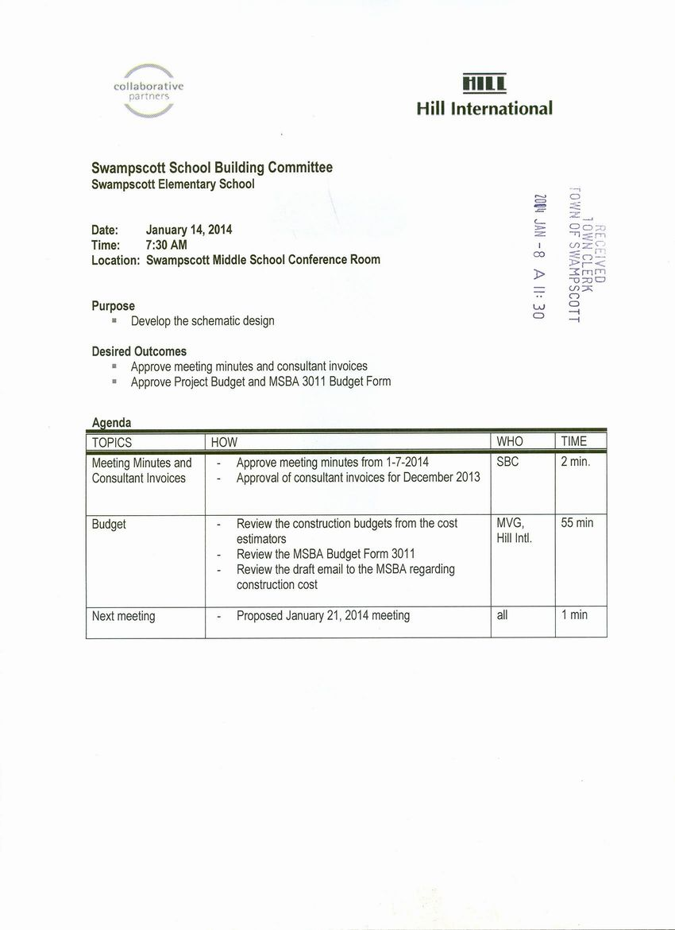](http://www.town.swampscott.ma.us/Public_Documents/SwampscottMA_Calendar/S04501AD4-045020BD.0/School%20Building%20Committee%20Jan%2014th%20notice%20001.jpg)